Liam Lachs
l.lachs2@newcastle.ac.uk
www.coralssistlab.org

Bio
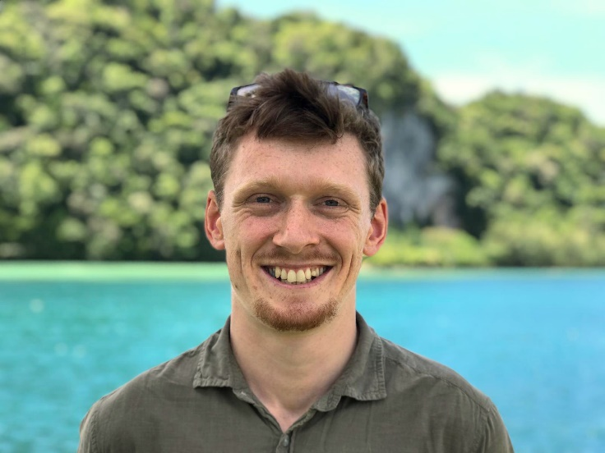
Having grown up surfing up and down the Irish west coast, I have a wide interest in our oceans and the marine sciences. My research has focussed on coral reef ecosystems, whether about food-supply in the Irish deep sea, sewage-influence on Malaysian reefs, demography of Australasian reefs (Palau, Okinawa and Australia), or global studies of shallow-water coral reefs. Corals have captivated my attention – they are the ecosystem engineers of coral reefs, they have a fundamental importance to maintaining ecosystem function, but they are also such a diverse group of organisms with so many stones still unturned.

Research Questions
The research for my PhD lies in the intersection between thermal biology, reef ecology, and climatology / climate change. I am assessing thermal impacts of corals across multiple spatial and temporal scales:
- Individuals: trade-offs between heat tolerance and other adaptive coral traits.
- Populations: heat stress effects on demographic processes like recruitment, growth and mortality.
- Ecosystems: Optimising the prediction of coral bleaching for all reefs globally based on heat stress metrics.
- Temporal Change and Adaptation: Testing whether corals can keep pace with climate change through natural selection and assessing the feasibility of restoration/rehabilitation activities to boost natural adaptation rates.

Techniques
I am employing various quantitative methods, from mixed effects modelling and sensitivity analyses, to Bayesian inference and spatiotemporal explicit models. I am using small-scale experiments and 3D photogrammetry to test specific hypotheses about coral trait trade-offs. Then, I am applying this to larger scales using spatially explicit individual based models that accounting for larval connectivity. I will assess coral responses under different climate scenarios using the world leading CMIP6 climate models and Shared Socioeconomic Pathways (SSPs).

Supervisors
- James Guest, CORALASSIST, Newcastle University, UK
- John Bythell, School of Natural & Environmental Sciences, Newcastle University, UK
- Holly East, Department of Geography and Environmental Sciences, Northumbria University, UK
- Peter Mumby, Marine Spatial Ecology Lab, University of Queensland, AU

Collaborations
- Maria Beger, University of Leeds, UK
- William Skirving, Coral Reef Watch, National Oceanic and Atmospheric Administration, USA
- Renata Ferrari, ecoRRAP, Australian Institute of Marine Sciences, AU
- Simon Donner, Climate and Coastal Ecosystems Laboratory, University of British Columbia, CA (c.f. UKRI-Mitacs Globalink Exchange)

Peer-review Publications
- L. Lachs, B. Sommer, J. Cant, JM. Hodge, HA. Malcolm, JM. Pandolfi, M. Beger (in press) Linking population size structure, heat stress and bleaching responses in a subtropical endemic coral
- L. Lachs, N.A.M. Johari, D.Q. Le, C.D.M. Safuan, N.N. Duprey, K. Tanaka, C.H. Tan N.C. Ory, Z. Bachok, D.M. Baker, M. Kochzius, K. Shirai (2019) Effects of tourism-derived sewage on coral reefs: Isotopic assessments identify effective bioindicators. Marine Pollution Bulletin. 148 pp. 85-96. doi:10.1016/j.marpolbul.2019.07.059.
- L. Lachs, J.O. Casado (2019) Fisheries and tourism: social, economic and ecological trade-offs in coral reef systems. In: V. Liebich, M. Bode & S. Jungblut (eds.) YOUMARES 9 – The Oceans: Our Research Our Future, Proceedings of the 2018 conference for YOUng MARine RESearchers in Oldenburg, Germany.
- L.Q. Dung, K. Tanaka, L.V. Dung, S.Y. Fui, L. Lachs, S.T.S.A. Kadir, Y. Sano & K. Shirai (2017) Biomagnification of total mercury in a mangrove lagoon food web in the east coast of Peninsular Malaysia. Regional Studies in Marine Science. 16. pp. 49-55. doi:10.1016/j.rsma.2017.08.006.

Other Publications
- J. Guest, … L. Lachs, et al. (2020) The CORALASSIST Project: Testing novel conservation interventions to help coral reefs survive the climate crisis. ECOmagazine.
- A. Humanes, L. Lachs (2020) Remote sensing in managing, maintaining, and understanding coral reef ecosystems. United Nations Office for Outer Space Affairs.
- A. Cobley, R. Ross, N. Piechaud, L. Lachs, & J. Davison (2015) Mapping the deep: Striking coral gold off the coast of Ireland! Deep-Sea Life. 6. pp. 2-5.

